Ideation Phase
Brainstorm & Idea Prioritization Template

Date | 31 January 2025
Team ID | LTVIP2025TMID32756
Project Name | Pollen’s Profiling:Automated Classification Of Pollen Grains
Maximum Marks | 4 Marks

Brainstorm & Idea Prioritization Template:
step1: Problem Definition
Problem Statement:Manual pollen classification is time-consuming and prone to human error, limiting scalability in environmental monitoring, allergy research, and paleoclimatology.
Goal:Develop an accurate (>95%), automated system for rapid pollen grain classification.
Key Challenges:
High morphological variability across pollen species
Need for high-throughput processing (real-time capability)
Limited labeled datasets for rare species
Integration with existing microscopy systems
Step 2: Brainstorming
Technical Solutions
1. Deep Learning Models
CNN architectures (ResNet, EfficientNet) for image classification
Vision Transformers (ViTs) for capturing fine-grained features
Few-shot learning for rare species with limited data
2. Enhanced Imaging Techniques
Multi-spectral imaging to capture texture/surface patterns
3D microscopy for volumetric analysis
Automated slide scanning with high-resolution cameras
3. Hybrid Approaches
Combine ML with traditional morphometrics (size, pore count)
Active learning: Human-in-the-loop for ambiguous cases
Generative AI to augment training data (synthetic pollen images)
4. Deployment Strategies
Edge AI for field-portable devices
Cloud-based API for research collaboration
Mobile app for citizen science data collection
Step 3: Prioritization
Idea Impact (1-5) Feasibility (1-5) Notes
CNN + Transfer Learning: 5 5 Quick win; leverages existing models
Multi-spectral Imaging 4 3 Higher cost but improves accuracy
Few-shot Learning 4 2 Needs R&D for rare species
Edge AI Deployment 3 4 Useful for field applications
Criteria:
Impact: Accuracy gains, scalability, and user adoption.
Feasibility: Cost, technical complexity, and data availability.
Step 4: Action Plan
Top 3 Prioritized Ideas:
1. Develop CNN-based classifier (Transfer learning) → Owner: ML Team, Deadline: 3 months
2. Build labeled dataset (Collaborate with botanists) → Owner: Data Team, Deadline: 2 months
3. Prototype cloud API for scalable processing → Owner: DevOps, Deadline: 4 months
Risks/Mitigations:
Risk: Limited training data → Solution: Use data augmentation/GANs.
Risk: Hardware costs → Solution: Start with open-source tools (TensorFlow, OpenCV).
Step-1: Team Gathering, Collaboration and Select the Problem Statement
To initiate the project Pollen's Profiling: Automated Classification of Pollen Grains, the first step involved assembling a multidisciplinary team of individuals with complementary skills and interests. The team was formed with members from diverse academic and technical backgrounds, including biology, computer science, machine learning, and data analysis. This diversity ensured a comprehensive approach to understanding both the biological complexity of pollen grains and the technical demands of automation and classification.
Team Collaboration
Regular brainstorming sessions were conducted to discuss the scope, feasibility, and innovative aspects of the project.
Tools such as Google Meet, WhatsApp groups, Trello boards, and Google Docs were utilized for effective communication and collaboration.
Roles were distributed based on individual strengths: some members focused on research and data collection, others on model development, UI/UX, and report writing.
Problem Statement Selection Process
The team reviewed multiple real-world challenges in palynology (the study of pollen).
After evaluating various problems, the team recognized that manual classification of pollen grains is time-consuming, error-prone, and requires expert knowledge.
Based on this insight, the following problem statement was selected:
"To design and implement an automated system that accurately classifies different types of pollen grains using advanced image processing and machine learning techniques, thereby reducing the need for manual intervention and improving classification accuracy."*
This problem was considered significant due to its potential to assist researchers in environmental monitoring, allergy forecasting, and biodiversity studies.
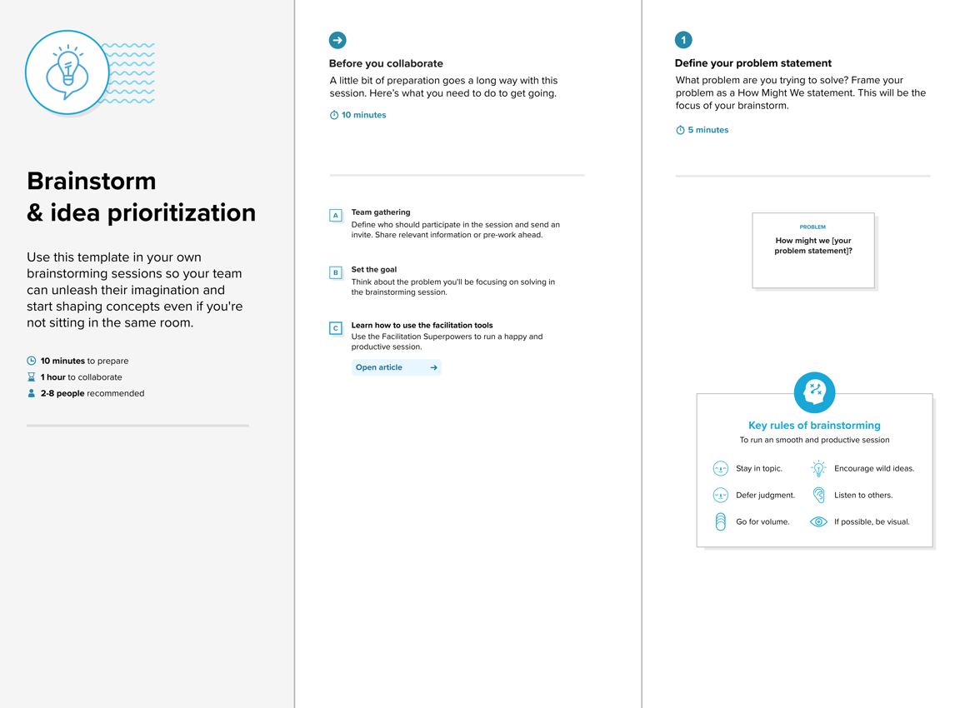

Step-2: Brainstorm, Idea Listing and Grouping
---
Brainstorming:
The objective is to automate the classification of pollen grains using image processing and machine learning techniques, helping researchers analyze samples faster and more accurately.
---
Idea Listing
1. Data Collection
Gather high-resolution microscopic images of different pollen types.
Collect labeled datasets from botanical or palynology research centers.
Use open-source image databases like PalDat or NASA pollen datasets.
2. Image Preprocessing
* Noise removal (Gaussian blur, median filter).
* Contrast enhancement (Histogram equalization).
* Resize and normalize images for input to model.
* Edge detection or segmentation (e.g., using Sobel, Canny).
3. Feature Extraction
Shape-based features (size, circularity, edge contours).
Texture features (Gabor filters, Local Binary Patterns).
Color-based features (if colored images are available).
Deep features using CNN (Convolutional Neural Networks).
4. Model Selection
Traditional ML: SVM, KNN, Decision Trees, Random Forest.
Deep Learning: CNN, ResNet, VGG, MobileNet.
Compare accuracy across models.
5. Classification System
Real-time prediction using trained model.
Multi-class classification for different pollen types.
Confidence score with prediction.
6. Automation Tools
Build an automated pipeline (image → preprocessing → prediction).
Integration with microscope camera system.
Dashboard for uploading and analyzing images.
7. Evaluation Metrics
* Accuracy, Precision, Recall, F1-Score.
* Confusion matrix visualization.
* ROC curve for binary classifications (if applicable).
8. Deployment
Web app or mobile app for researchers.
Cloud storage for dataset and model.
Auto-update feature for new pollen classes.
9. Challenges & Solutions
Similar appearance of some pollen grains → Use higher feature granularity.
Dataset imbalance → Use data augmentation or SMOTE.
Limited data → Transfer learning using pretrained models.
Grouping of Ideas (Mind Map Style)
1.Data Management
Image dataset collection
Labeling and annotation
Data augmentation
2. Preprocessing & Feature Engineering
Noise reduction
Edge detection
Texture/Shape/Color feature extraction
3. Machine Learning Models
SVM, KNN, Random Forest
CNN-based Deep Learning
Ensemble methods
4. Model Training & Testing
Cross-validation
Evaluation metrics
Hyperparameter tuning
5. Automation&Integration
Full image analysis pipeline
Integration with microscope hardware
Real-time results display
6. Visualization & User Interface
Dashboard with prediction results
Graphs of performance metrics
User-friendly input method
7. Deployment & Accessibility
Web/mobile app
Cloud-hosted system
Data export options
8. Maintenance & Future Enhancements
New pollen type addition
User feedback integration
Continuous model retraining

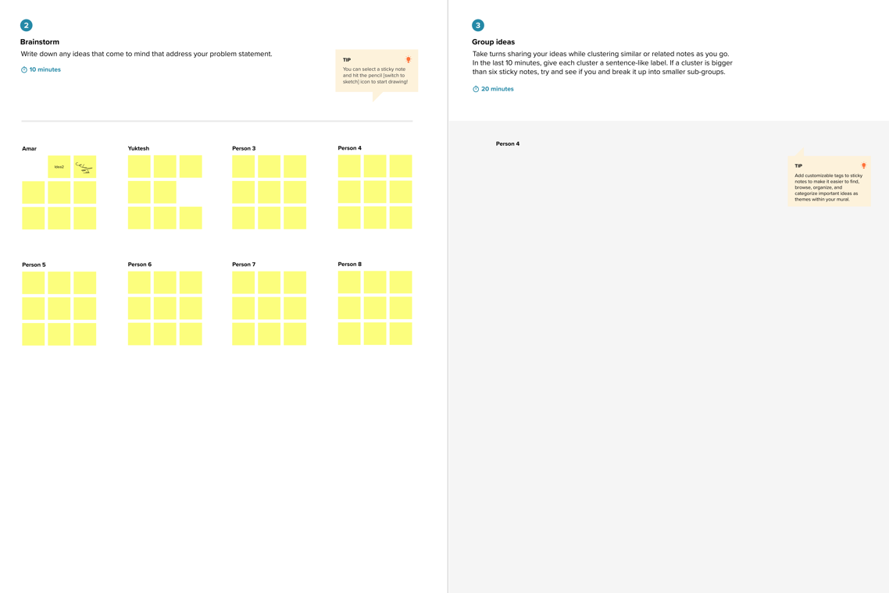

Step-3: Idea Prioritization

1. Collect & Clean Pollen Images
Get clear microscope photos of different pollen types.
Remove bad/blurry images.
2. Train a Simple AI Model
Start with a basic CNN (like ResNet or MobileNet).
Test accuracy on known pollen samples.
3. Check if it Works in Real Life
Try classifying new pollen images.
Fix major errors (e.g., confusing similar-looking pollens).
Next Steps
4. Make it faster (for mobile/field use).
5. Add more pollen types (expand dataset).
6. Show why the AI made its choice (explainability).
Optional
7. Count pollen grains automatically.
8. Add weather/seasonal data for better predictions.
